Habitat connections

Name_____________________ Class_______________ Date________

A woodland food web
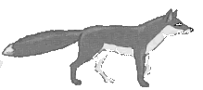
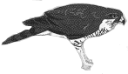
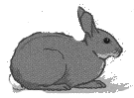
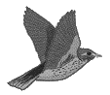
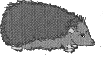
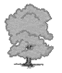
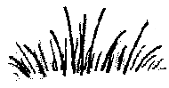
hawk
thrush
caterpillar
oak tree
hedgehog
slug
fox
rabbit
grass

1

a) There are eight food chains within this woodland food web. Can you find them all and write them out? One has been done for you.

oak tree → slug → thrush → hawk
_______________________________________________________________ __
__________________________________________________________________________________________________________________________________________________________________________________________________________________________________________________________________________________________________________________________________________________________________________________________________________ __

- Circle all the predators in your food chains in red and their prey in blue. (Some organisms will have both a red and a blue circle around them.)

2 Organisms have special features to survive in their habitat. These are called adaptations.

a) How is a hawk adapted to be an efficient predator?
____________________________________________________________________
____________________________________________________________________

- How is a hedgehog adapted to survive?
___

3 Look at the food web again. Some organisms compete with each other for the same food.
Complete the table to show the competing organisms and the food they compete for.

Competing organisms | Food

a) How would the hedgehogs survive if all the slugs died out?
____________________________________________________________________
____________________________________________________________________

- What might happen to the number of thrushes if all the slugs died out?
____________________________________________________________________
____________________________________________________________________

4 In the wood there would also be flowers, such as foxgloves, and bees.
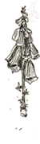

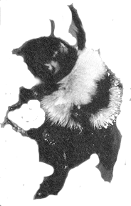

- How do the bees depend on the foxgloves for their survival?
____________________________________________________________________

- How do the foxgloves depend on the bees for their survival?
____________________________________________________________________

5 Many organisms in the wood will depend on the oak tree for their survival. One example is for food. Can you think of any other ways that organisms depend on the tree to survive?
________________________________________________________________________________________________________________________________ ____

6 Read the following information about organisms that live in a pond.

- Pike eat perch and water rats.
- Tadpoles and minnows eat pondweed.
- Perch eat tadpoles and minnows.
- Water beetles eat small tadpoles.
- Water rats eat water beetles.

- Show this information as a food web.

- What is the top predator in this food web? ________________________________

- Which organism competes with the perch for food? _________________________

d) What factors will affect where the water beetles will be found in the pond?

Make a list.

